TOOLS FOR PAINTING AND DECORATION

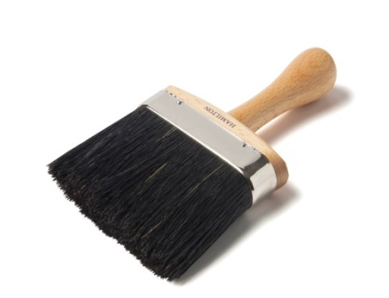
DUST BRUSH
Dusty-Brush is a universal vacuum cleaner attachment for the smallest areas, delicate objects and hard-to-reach areas.

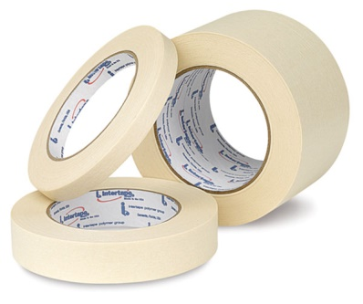
MASKING TAPE
Masking tape, also known as painter's tape, is a type of pressure-sensitive tape made of a thin and easy-to-tear paper, and an easily released pressure-sensitive adhesive. It is available in a variety of widths. It is used mainly in painting, to mask off areas that should not be painted.

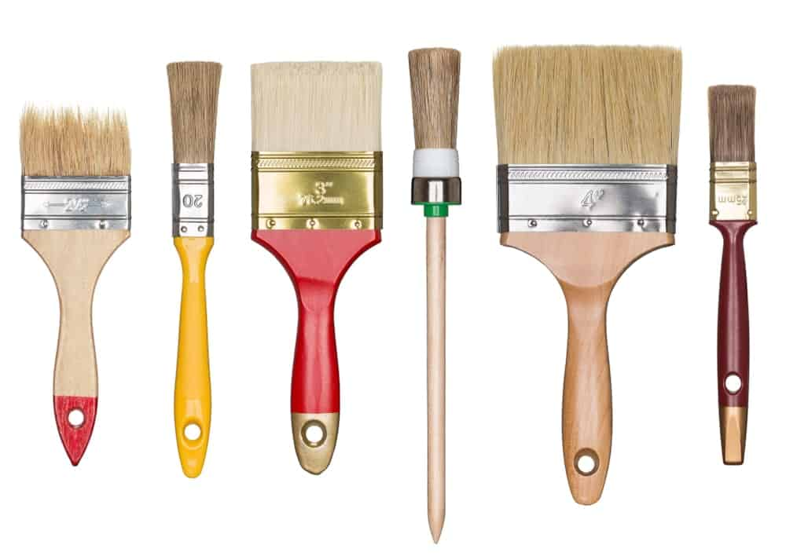
PAINT BRUSH
A paintbrush is a brush used to apply paint or sometimes ink. A paintbrush is usually made by clamping the bristles to a handle with a ferrule. They are available in various sizes, shapes, and materials. Thicker ones are used for filling in, and thinner ones are used for details.

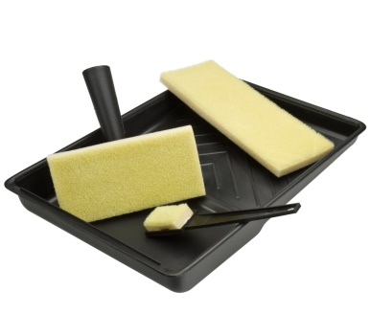
PAINT PAD
Paint pad is a flat, usually rectangular paint applicator. It has an easy-to-hold handle on the back, and the front is foam covered in short, densely-packed bristles. Paint pads come in different sizes, so that you can pick the size that is most suitable for the painting job you need to do.

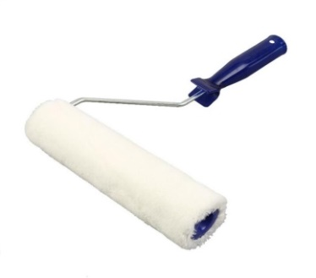
PAINT ROLLER
A paint roller is a paint application tool used for painting large flat surfaces rapidly and efficiently. The paint roller typically consists of two parts: a "roller frame," and a "roller cover.

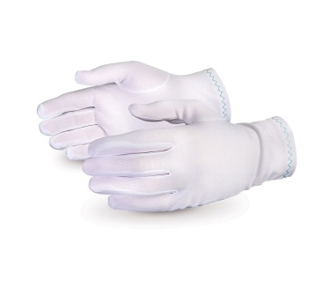
PAINTERS MITTS
It is built with a moisture-proof plastic lining which allows the wearer to submerge their gloved hand into a container of paint or stain, and then use the thick, absorbent fabric-covered mitt to apply paint to challenging surfaces or tight areas.

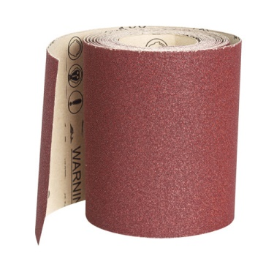
SAND PAPER
Sandpaper and glasspaper are names used for a type of coated abrasive that consists of sheets of paper or cloth with abrasive material glued to one face. Sandpaper is produced in a range of grit sizes and is used to remove material from surfaces, either to make them smoother (for example, in painting and wood finishing), to remove a layer of material (such as old paint), or sometimes to make the surface rougher (for example, as a preparation for gluing).

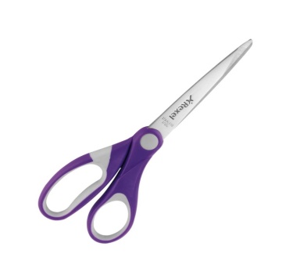
SCISSORS
Scissors are hand-operated shearing tools. A pair of scissors consists of a pair of metal blades pivoted so that the sharpened edges slide against each other when the handles opposite to the pivot are closed.

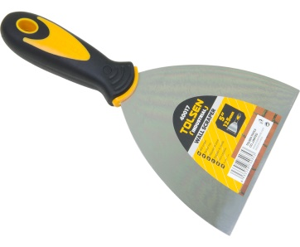
SCRAPER
Paint Scrapers and blades are great for helping remove paint, glue, putty or adhesives from glass, tile, walls, floors or other smooth surfaces.
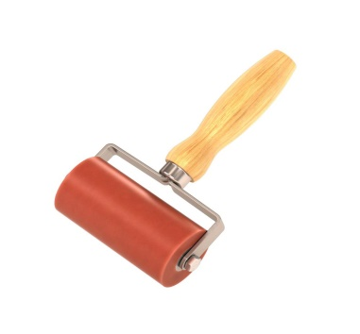
SEAM ROLLER
Safety boots are shoes made with a protective reinforcement at the front making them quite durable. The reinforcement helps to protect the toes from falling objects or any kind of compression. They are normally installed with a sole plate in the main sole to prevent against punctures that may come from below.

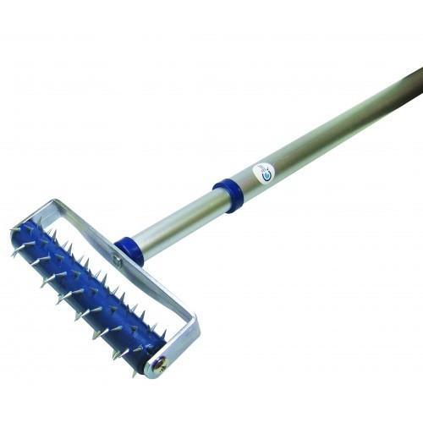
WALLPAPER PERFORATOR
The wallpaper perforator, which is also known as a spiked roller or perforating roller, is a typical and immensely useful tool for removing paper-based wallpapers. ... The wallpaper perforator also gives you better access to the sub-layers of painted-over or sealed wallpapers.

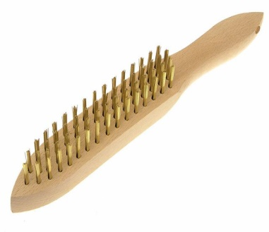
WIRE SCRATCH BRUSH
Scratch brushes with pen-shaped handles are used for removing rust or corrosion in hard to reach places. Made with metal ferrules for improved durability.

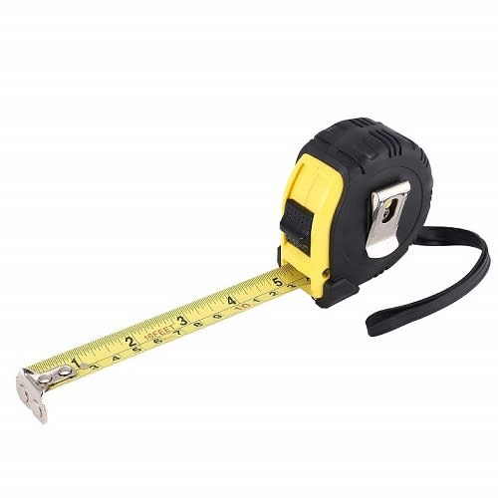
TAPE MEASURE
A tape measure or measuring tape is a flexible ruler used to measure distance. It consists of a ribbon of cloth, plastic, fibre glass, or metal strip with linear-measurement markings. It is a common measuring tool.

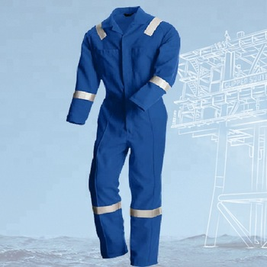
COVERALL
A one-piece protective garment worn for heavy manual work; a boiler suit.

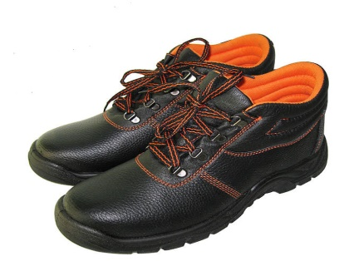
SAFETY WORK SHEOS (LEATHER)
Safety boots are shoes made with a protective reinforcement at the front making them quite durable. The reinforcement helps to protect the toes from falling objects or any kind of compression. They are normally installed with a sole plate in the main sole to prevent against punctures that may come from below.

